TEAM PAGE
LINK - https://www.safehaven-upllyft.com/team
Make the following changes
Add Team Members with Photos (Check Spelling)
- Lakshmi Nair – Ecosystem Lead
- Rajesh Parameswaran – Ecosystem Lead
- Rahul Ramesh - Volunteer Programme Lead
- Sutharsan CP - Volunteer Programme Lead

Strategic Advisory Team Members
Upllyft is supported by a strategic advisory team of experts in neurodivergence, special education, disability inclusion, and community-based care.

Ms Richa Bansal
- Founder & Director at Saarathee, Transforming Disability Inclusion
- https://www.linkedin.com/in/richa-bansal-3a55a7b0/

Dr. Sini Regi Thomas
- Group Head, Department of Special Educational Needs at Trivandrum International School, Kerala, India.
- https://www.linkedin.com/in/dr-sini-regi-thomas-40193b217/

Ms. SWATHEE ELAMON
- SPEECH LANGUAGE PATHOLOGIST
- http://www.wellnessone.in/our-specialists.html

Kanaga
- Title
- Link

Shrividhya
- Title
- Link
Key Partner Organisation
Al-Noor Crid (See Al-Noor document) to get a small summary of this partnership.
LANDING PAGE CHANGES
1. The centering of the picture is not correct with the circle
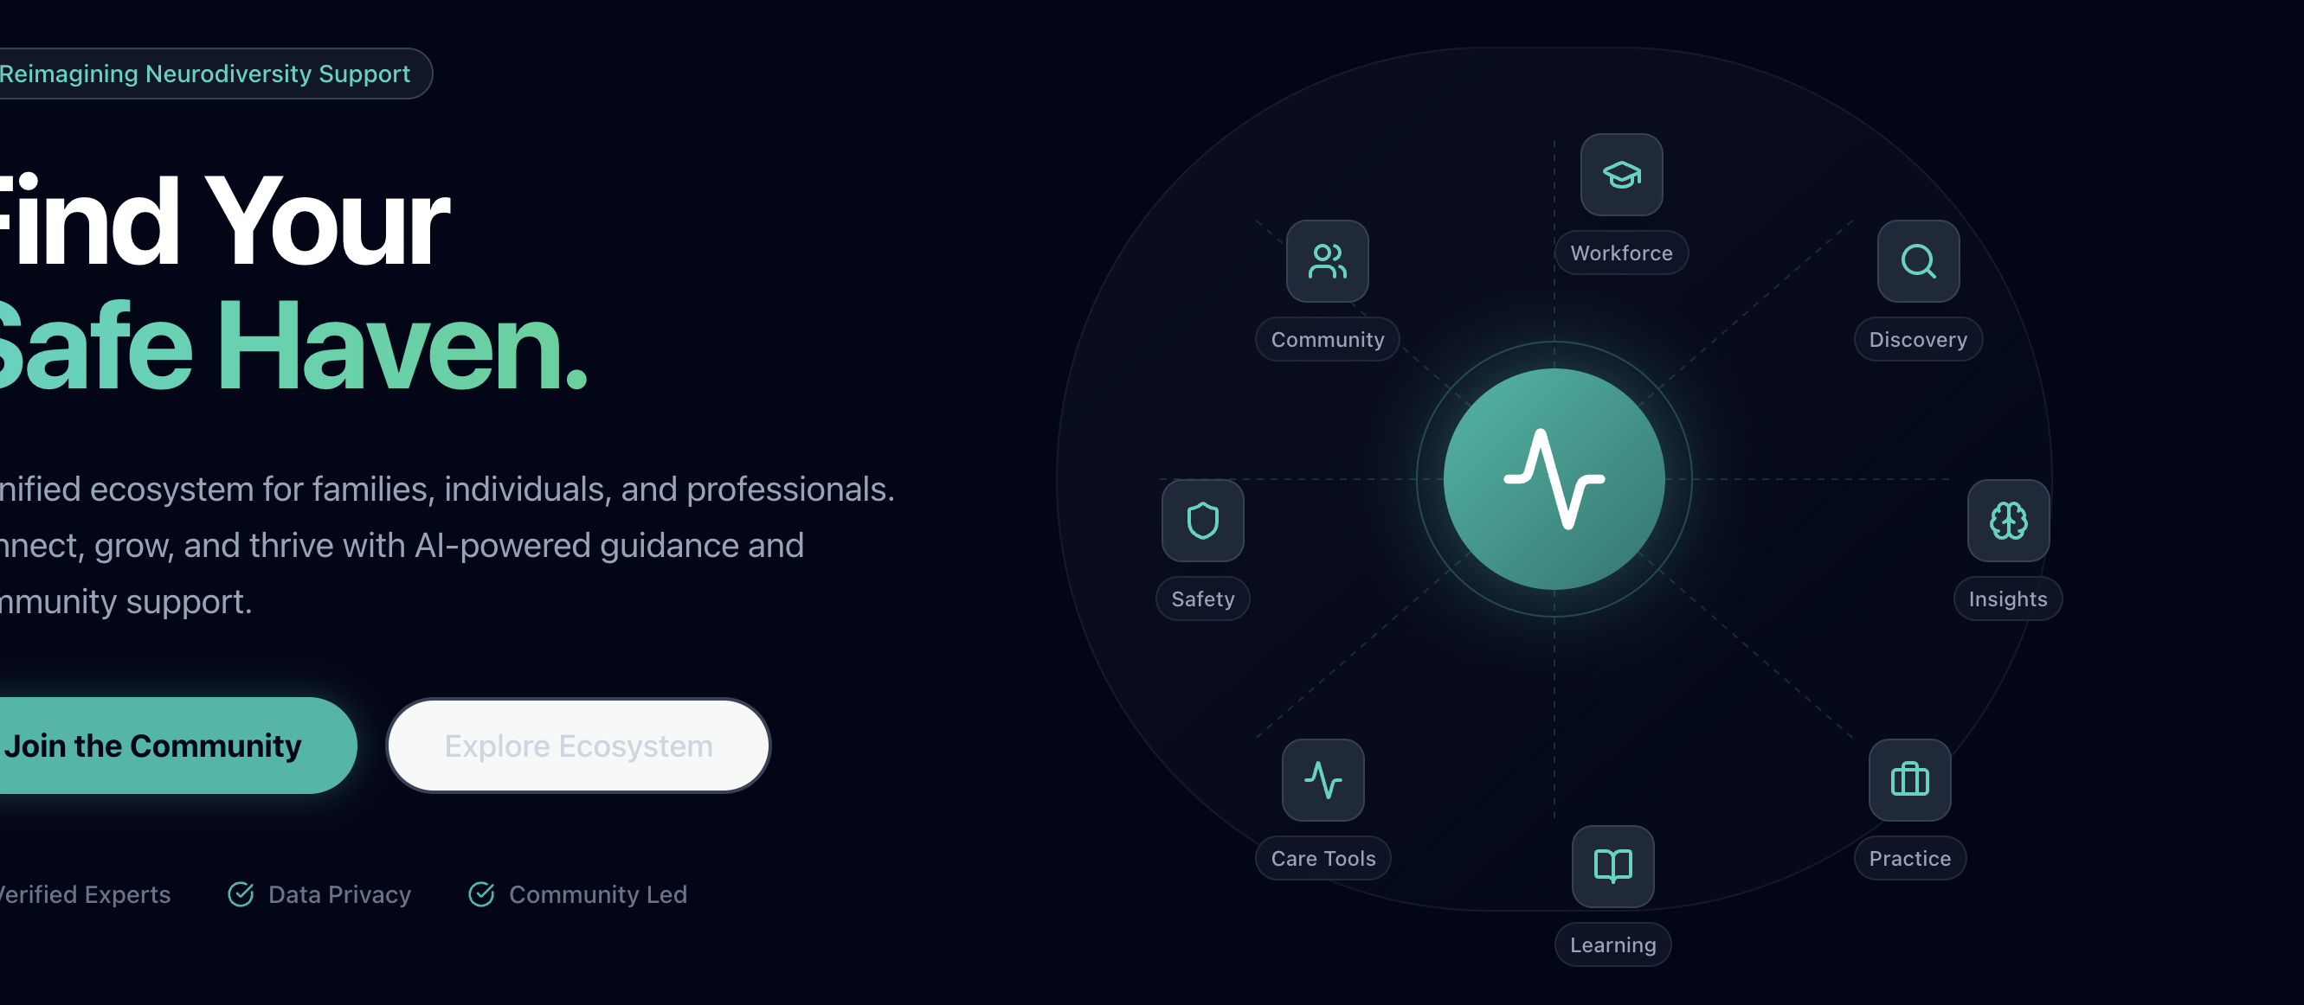

2. ADD A SECTION TO INTRODUCE OUR TWO LAYERS
One ecosystem. Two connected experiences.
Upllyft brings together families, caregivers, professionals and organisations through two connected platform experiences.
Upllyft Compass supports families with structured guidance, trusted resources, community connection and better-fit support discovery.
Upllyft PracticeOS supports clinics, therapists and care organisations with intake, booking, care planning, documentation, progress tracking and continuity workflows.
Together, they help reduce fragmentation across home, clinic, school and community - so support becomes more connected, practical and continuous.

3. Add two more pages on the top header along with the other page sites

Page 1

Upllyft Compass

Hero section
Upllyft Compass
Clearer guidance for families navigating neurodivergence.
From first questions to practical next steps, Upllyft Compass helps parents, caregivers and individuals access structured guidance, trusted resources, peer support and better-fit professional connections — all in one place.
CTA: Join the community
Secondary CTA: Explore how it works

Section 1: Why families need more than information
Families are often surrounded by information but still left without direction. Advice is scattered across WhatsApp groups, social media, school conversations, therapist recommendations and online searches. The result is confusion, delay and repeated restarting.
Upllyft Compass helps families move from uncertainty to clearer action by organising questions, surfacing relevant resources and connecting them to people, professionals and pathways that fit their context.
Section 2: What families can do with Upllyft Compass
- Ask better questions
Turn open-ended concerns into structured guidance and practical next steps.
- Access trusted resources
Find learning material, explainers, checklists and tools designed for real family situations.
- Connect with similar families
Join moderated community spaces shaped around lived experience, needs and life stage.
- Discover better-fit professionals
Find therapists, clinicians, educators and organisations based on context, language, approach and support needs.
- Build continuity over time
Keep guidance, resources, conversations and care actions connected as the child or individual’s needs evolve.
- Support school and home alignment
Access practical inclusion resources and guidance that can help families work better with schools and professionals.

Section 3: How it works
Step 1: Share what you are looking for
A parent or caregiver asks a question, describes a concern or explores a topic.
Step 2: Get structured guidance
Upllyft helps organise the concern into clearer next steps, relevant resources and possible support options.
Step 3: Connect with the right support
Families can discover professionals, community groups, learning resources or services that may be relevant.
Step 4: Continue the journey
As needs change, families can return to their pathways, resources and community instead of starting again from zero.

Section 4: Built for families, not generic engagement
Upllyft Compass is not another social feed. It is designed to reduce noise, improve clarity and help families take practical steps with confidence.
Designed for:
Parents
Caregivers
Neurodivergent individuals
Extended family members
Families seeking therapy or educational support
Families looking for peer connection and trusted resources

Section 5: Responsible guidance
Upllyft Compass does not replace professional advice, diagnosis or therapy. It is designed to support families with information, structure and clearer direction, while encouraging users to seek qualified professional guidance wherever clinical, therapeutic or medical input is required.
Page 2

Upllyft PracticeOS

Hero section
Upllyft PracticeOS
A connected workspace for clinics, therapists and neurodivergent care teams.
Upllyft PracticeOS helps professionals manage intake, bookings, assessments, care plans, session notes, parent communication, progress tracking and continuity of care — without relying on disconnected spreadsheets, WhatsApp messages and manual follow-ups.
CTA: Request a demo (SHOULD TAKE YOU TO THE CONTACT US PAGE AND FILL IN THE FORM)
Secondary CTA: See platform capabilities

Section 1: Why professionals need a better operating layer
Therapists, clinicians, educators and centres work hard to support families, but care delivery is often fragmented. Intake forms sit in one place, appointments in another, therapy notes somewhere else, and parent communication happens across informal channels.
This makes it harder to maintain continuity, track progress, coordinate across professionals and support families between sessions.
Upllyft PracticeOS gives professionals a structured digital layer to manage the care journey more clearly.

Section 2: What professionals can manage
Client intake and onboarding
Capture family details, concerns, referral information, background history and initial support needs.
Appointment and booking workflows
Manage consultations, therapy sessions, follow-ups, cancellations and rescheduling.
Therapist allocation
Assign cases based on need, availability, discipline, location, language or service type.
Assessments and care planning
Create structured assessments, goals, intervention plans and review timelines.
Session notes and progress tracking
Document observations, therapy activities, progress, concerns and next actions.
Parent communication
Share updates, home recommendations, resources and follow-up actions in a more organised way.
Reports and documentation
Generate summaries, progress reports, intervention notes and review outputs.
Multi-disciplinary coordination
Support better handoffs between speech therapists, occupational therapists, psychologists, special educators, physiotherapists and centre administrators.
Organisation visibility
Help centres and organisations understand caseloads, service demand, follow-ups, outcomes and operational bottlenecks.

Section 3: How it works
Step 1: Receive enquiry or referral
A family reaches out through the website, community, walk-in, social media, referral partner or professional channel.
Step 2: Complete intake
The centre or professional captures the required intake details and understands the family’s needs.
Step 3: Allocate the right professional
The case is assigned to the right therapist, clinician or care team.
Step 4: Assess and plan
Professionals complete assessments, define goals and create a care or intervention plan.
Step 5: Deliver and document sessions
Each session can be recorded with structured notes, observations and next steps.
Step 6: Track progress and communicate
Families receive clearer updates, while professionals maintain continuity across sessions.
Step 7: Review, report and adapt
Care plans can be reviewed over time based on progress, changing needs and professional judgement.

Section 4: Built for the neurodivergent care ecosystem
Upllyft PracticeOS is designed for the professionals and organisations supporting neurodivergent individuals and families.
Designed for:
Therapy centres
Speech and language therapists
Occupational therapists
Psychologists
Special educators
Physiotherapists
Developmental professionals
NGOs and inclusion organisations
Schools and support teams
Multi-disciplinary care teams

Section 5: What makes it different
Most practice tools focus only on appointments or administration. Upllyft PracticeOS is designed around continuity of support.
It connects the operational side of care with the wider Upllyft ecosystem — families, resources, community, guidance, professional discovery and long-term support.
This means professionals are not just managing sessions. They are helping families stay better supported between sessions.

Section 6: Responsible professional use
Upllyft PracticeOS supports documentation, coordination and care workflow management. It does not replace professional judgement, clinical responsibility or regulatory obligations. Professionals remain responsible for assessment, diagnosis, intervention and therapeutic decision-making in line with their qualifications and applicable regulations.

MISSION PAGE
Link – https://www.safehaven-upllyft.com/mission

Changes are the following

The picture against the text is not available. Create a relevant image/icon relevant to this text

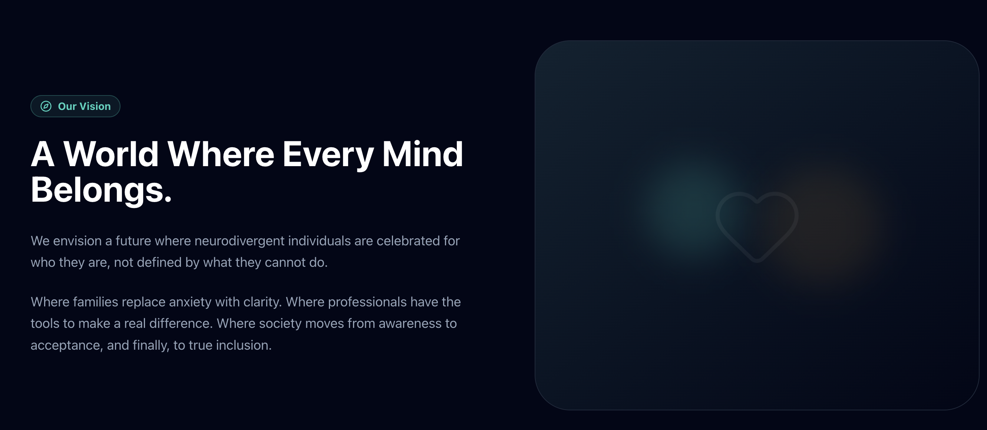

DEFECT

Noticed that when I click on any of the pages from the header bar, like mission for example, then on the page, the header disappears. See below image for reference
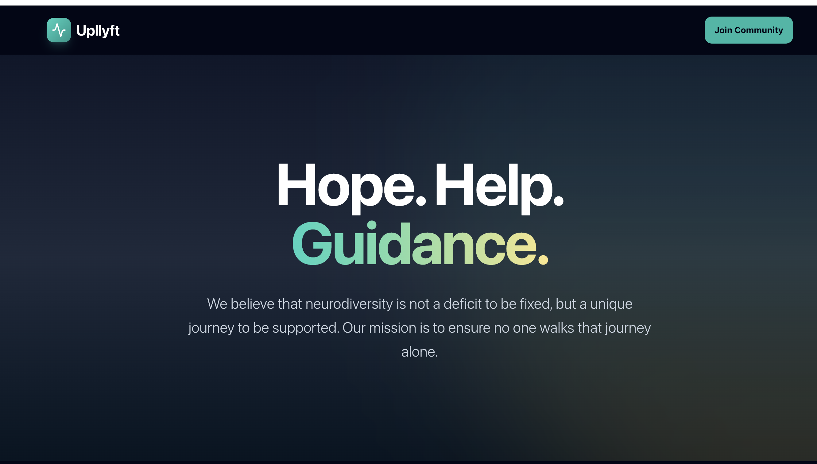

PARTNERSHIPS
There is a partners page in the footer. Bring that to the top in the and create a sub-page Al-noor with the content provided in the Al-Noor document.

